Boat Name _________________________________________________

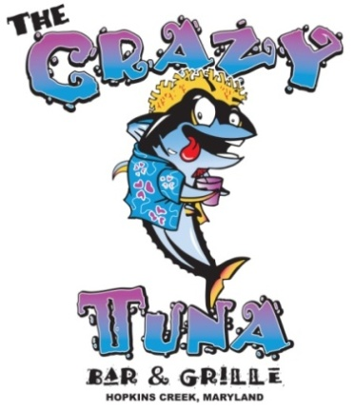

2017 Crazy Tuna
Spring Rockfish Tournament

May 13, 2017

Deadline for registration is May 11, 2017

Registration Fee: $200 per boat with a
maximum of 4 Anglers

Boat Captain ________________________________________Angler #____________

Angler #2____________________________________________Angler #____________

Angler #3____________________________________________Angler #____________

Angler #4____________________________________________Angler #____________

Additional Anglers at a fee of $60 per person:

Angler’s Name ________________________________________Angler #___________

Angler’s Name ________________________________________Angler #___________

Angler’s Name ________________________________________Angler #___________

By signing and submitting this entry form all Captains accept responsibility for the safety of their crew and release The Crazy Tuna and all managing bodies from any and all liability.

Captain’s Signature ____________________________Phone_____________ Date ________

Make Checks Payable To: The Crazy Tuna
203 Nanticoke Road
Middle River, MD 21221

